Contact person for editorial offices:
Dirk Rott, Head of Marketing

February 6th, 2019

Press release WA1901 English: Universal Industrial Ethernet Encoder

Images and text are approved for publication in the press (print and online). Please send us a specimen copy after publication. Thank you for your efforts in advance.
________________________________________________________________________
World first: Universal Industrial Ethernet Encoder
One click, lots of protocols
The right encoder is always available in stock
Mechanical engineers and plant engineers work with various controllers and protocols, depending on the region the target market is in or the sector in which the end user operates. Typically, the components are then specifically tailored to the protocol of the controller that is being used and the components, such as encoders for measuring length, position and speed, need to be programmed for each protocol. Distributors and mail-order retailers also need to keep various models in stock in order to be in a position to supply the large number of available protocols.
Now, the WDGA Universal Industrial Ethernet Encoder by Wachendorff Automation greatly simplifies these stock issues for mechanical and plant engineers, as well as for distributors and mail-order retailers. This is because the required protocol is only imported via the encoder’s website when the relevant encoder is actually used. This works even without needing to use any additional tools or programming adapters. All you need is a PC with a network card, with a freely adjustable IP address, and the web browser of your choice. The process only takes a few minutes. You can use PROFINET or EtherCAT just-in-time to get started with the new type of encoder: Additional protocols will follow soon. In 2019, ethernet/IP will be added.
In addition, extremely high bearing loads guarantee a long service life and high levels of endurance. As well as outstanding mechanical properties, the most up-to-date electronic components, communication profiles and encoder profiles are used. These extremely robust absolute encoders, which feature a magnetic scanning function, can be used in situations where in the past only optical absolute rotary encoders could be used. This is because the new encoders feature highly precise and dynamic EnDra® and QuattroMag® technology.
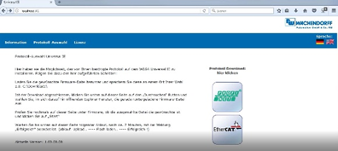
Image (Wachendorff Automation):

