Contact person for editorial offices:
Dirk Rott, Head of Marketing

March 4th, 2019

Press release WA1902: Length measuring system LMS MA with absolute encoders

Images and text are approved for publication in the press (print and online). Please send us a specimen copy after publication. Thank you for your efforts in advance.
________________________________________________________________________

The innovative length measuring system LMS MA
... can now be combined with absolute encoders

The length measuring system LMS MA is a very space-saving, reliable complete system for the measurement of position, speed and length.
Up to 0.003 mm/pulse provide excellent measurement results.
The system can be adapted to any surface due to the different running surfaces of the measuring wheels. It is also very quickly mounted and adjusted.
Save the additional input card for incremental signals on your PLC. Select an absolute encoder from the WDGA series, e.g. with CANopen, SSI, Profinet or EtherCAT.
More information:
https://www.wachendorff-automation.com/length-measurement-system-information/

Image (Wachendorff Automation):

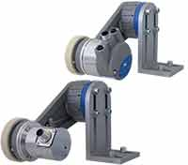
WA1902_Wachendorff_LMSMA_absolute_encoders.jpg

