Your contact:
Dirk Rott, Marketing Manager

27 April 2022
Press release WA22M2: WDGN … encoder configuration via NFC
Images and text material are released for publication in the trade press (print and online).
Please send us a specimen copy after publication. Thank you very much for your efforts.
_____________________________________________________________________

The worlds first configurable encoder by NFC
Unique in the world: Wachendorff encoder configurable via NFC
Contactless and voltage-free encoder configuration via NFC

The new WDGN series of incremental encoders from Wachendorff Automation enables configuration of any pulse count from 1 I/U to 16,384 I/U via NFC.
Depending on the equipment, Basic or Advance, further parameters can be set via APP using NFC.
After downloading the Wachendorff WDGN app to the smartphone, the desired parameters and values can be configured without contact or voltage, if necessary also through the outer packaging.
Encoder configurations created can be saved under different names, reloaded at any time and transferred to another encoder. This means that saved configuration sets can be used for the encoder in different applications. The configuration set of an encoder can be read out, saved, shared and reused for other encoders at any time after entering the PIN. The PIN and PUK principle is used for security.

The advantages for the user include the following:
- In the development phase, when there is uncertainty about which number of pulses the encoder needs to run optimally in an application, the WDGN encoder offers the necessary flexibility to test the optimum number of pulses. As soon as the optimum configuration has been found, the user receives an encoder with the same technological features for use in series production - but without an NFC antenna for cost reasons. A second qualification is no longer necessary.
- Optimum spare parts, logistics and warehouse management becomes possible. Never again will an encoder be sent with an incorrect pulse count. Because with the free app on the smartphone, communication with the encoder takes place via NFC, completely without an internet connection, and the desired parameter values can be set just-in-time by the recipient.
- In the application, the WDGN encoders offer a very high resolution of up to 16,384 I/U in a very compact design from 36 mm. This means that high-precision measurements can be realised in the smallest installation space.

More detailed information: www.wachendorff-automation.com/wdgn

App download for Android, Google Play Store (Huawei and IOS app to follow soon):
https://play.google.com/store/apps/details?id=de.wachendorff.wdgn

Image material (Wachendorff Automation):

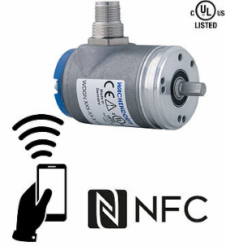
WA22M2_encoder_NFC_Wachendorff_print_1.jpg

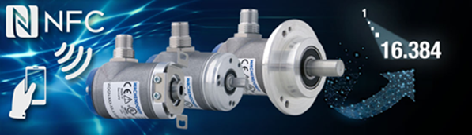
WA22M2_encoder_NFC_Wachendorff_internet_2.jpg

WA22M2_App_QRCode_Link_GooglePlayStore_3.jpg

Wachendorff Automation GmbH & Co. KG
Wachendorff Automation (Geisenheim/Germany) stands for the development and manufacture of innovative encoders, motor feedback and complete measuring systems for use in a wide variety of series applications in mechanical and plant engineering. The focus is on an extensive standard program with numerous options as well as the efficient development of customer-specific solutions. Sales offices in the USA and China.
The optimum combination of electronics, optics and mechanics make Wachendorff encoders the most robust, reliable and innovative devices on the market.
High protection classes, wide temperature ranges and the very robust electronics enable use also in very demanding applications.
Unique worldwide: 5-year warranty!
www.wachendorff-automation.com

Additional press material:
https://www.wachendorff-automation.com/latest-information/

