40 years of WACHENDORFF

A festive celebration as a thank-you

At the end of September, the Wachendorff Group celebrated this year's summer party - this year in the spirit of the company's 40th anniversary and therefore in a special setting.
CEO Robert Wachendorff had invited guests from all over the world. And they gladly and numerously followed his invitation to the Rheingau. More than 200 people - family, friends, companions, partner companies and last but not least employees with life partners - came together to celebrate a glittering anniversary celebration.
In his opening speech, Robert Wachendorff described the company's path in an amusing way: the germ cell, the family living room in Johannisberg in 1978; the move to Industriestrasse 7 in 1987; right up to the purchase of expansion space in 2018. It fitted very well into the picture that the very first Wachendorff trainee was present that evening as a guest of honour.
"You are the cornerstones of our worldwide growth", Robert Wachendorff welcomed the so-called technical distributors who ensure that the innovations "Made in Geisenheim" find their customers all over the world.
He honoured his employees as the "foundation of continuous, healthy growth from within" and thanked their relatives for "keeping their backs free in stressful times". He expressly emphasised that "this celebration is to be seen as a thank-you to his employees, and at the same time he is looking forward to many more years of cooperation in a spirit of partnership, because in recent years the basis for a successful future of the Wachendorff Group has been created at the Geisenheim location".
Such a celebration does not organize itself and Robert Wachendorff thanked the whole team in front and behind the scenes, which worked under the leadership of Berenike Wachendorff for half a year on this event.
The long lasting applause of all guests confirmed to the host and the organisation team that the right words and an optimal atmosphere had been found for this anniversary celebration.

Wachendorff_40years_01:
CEO Robert Wachendorff found the right words and was visibly proud and excited.

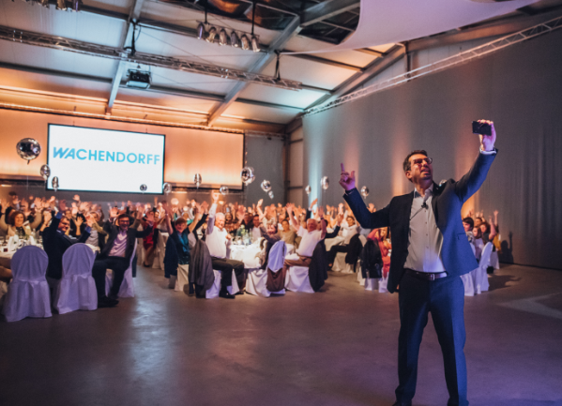

Wachendorff_40Years_02:
The Wachendorff family (Robert, Konstantin, Andrea and Berenike) under the sign of the "40".

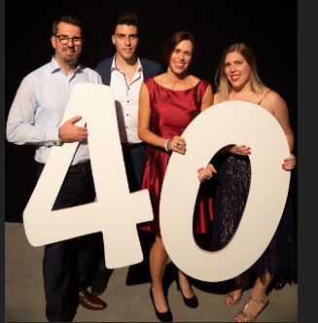

Wachendorff_40years_03:
More than 200 guests celebrated 40 years of WACHENDORFF together.

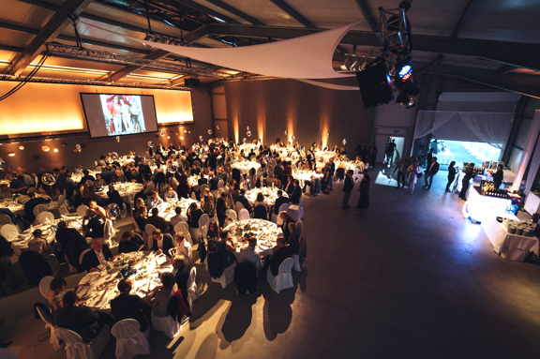

Wachendorff_40years_04:
Employees celebrated the company's anniversary and themselves with a lot of fun.

